# Lab 5

**Exercise 1-1:**

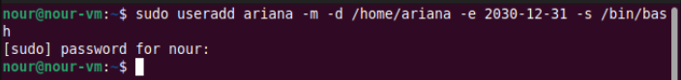

**Exercise 1-2:**



**Exercise 1-3:**

**Exercise 1-4:**

**  
Note:** Previous eighth field was 22279.

**Exercise 1-5:**



**Exercise 1-6:**

**Note:** no grep for dimona means the account is deleted/unavailable. Used as verification.

**Exercise 2-1:**

**Exercise 2-2:**

**Note: Password is Algonquin**

**Exercise 2-3:**

**Exercise 2-4:**



**Exercise 2-5:**

**Note:** Might need to add users to cdrom, adm, or sudo groups.

**Exercise 2-6:**

**Note:** password is `algonquin`

**Exercise 3-1:**

**Exercise 3-2:**

  
User’s default group is it’s own name. -N removes default grouping and -G adds the user to other groups.

**Exercise 3-3:**

**Exercise 3-4:**



**Note**: This is how you observe group association/membership of a user.

**Exercise 3-5:**

